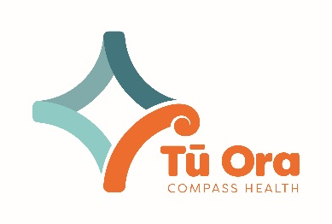**Standardisation Overview**

Title of Process/Resource: Standardisation

Date: June 2020

Standardisation Process/Resource purpose:

Improving and maintaining Standardisation brings huge benefits for users, these include minimising wastes in processes, but allowing staff to focus on being more creative and focussed on continuous improvemen .

**Standardisation - Best Practice in Action**

What is Standardisation ?

It is an agreed way of working a process, policy or practise.

Why should you Standardise?

Implementing standardisation will ensure the same quality of work will be delivered or completed each time. It ensures standard work is taken care of, thus giving greater opportunities to be creative and innovative . Standardisation supports consistency, regulation and quality.

Resources provided by Tū Ora

* One Point Lessons
* Issues registers
* Actions plans
* Checklists
* Process Mapping workshops
* Problem Solving workshops

Delivery/Training Needs:

-workshop -module  -face2face  -visit 

Resources the Practice needs to provide

* Lean Leader
* Lean team
* Invitation to visit
* Training Time

What do I need to do to Standardise?

* Understand the concepts of standardisation
* Decide on which areas you will work on
* Implement the standard work
* Consider how the work will be standardised ie: visually

What do I need to do to Standardise my workplace?

* Understand the concepts of standardisation
* Decide on which areas you will work on
* Implement the standard work
* Consider how the work will be standardised ie: visually

How do I Standardise our workplace?

* Use visual management
* Use visual display boards
* Use One Point Lessons

How will we know if Standardisation is working?

* Positive feedback from wider team
* Quality work produced every time
* More time to be innovative and creative, as standard work takes care of itself

What else could we consider?

* Are all areas standardised and what’s next

Internet Links:

<https://www.google.com/search?q=lean+standardisation&rlz=1C1CHBF_enNZ848NZ848&sxsrf=ALeKk01KKbNhxhEGw1YRi4co4cmGhkjdvQ:1591511919694&source=lnms&tbm=isch&sa=X&ved=2ahUKEwi06oP1i-_pAhXVzTgGHdsXBCoQ_AUoAXoECA4QAw&biw=1280&bih=578&dpr=1.5>

Supporting Legal documents: none

Clinical Best Practice: not applicable

Recommending reading:

<https://blog.gembaacademy.com/2009/04/06/12_leader_standard_work_questions_to_ask_on_the_ge/>