Pepeha basics
Description
Pepeha provide the means to present to others your tribal credentials to determine what
pre-exiting relationships, affiliations and obligations we have towards one another. A potential stranger can discover a basis to connect with someone based on what has been shared. Whakawhanaungatanga provides a great opportunity to share pepeha/ko wai au so that we may build good relationships and promote transparency.
The elements shared in this tool are all optional and not one pepeha is alike. Each represent a journey in both ones identity and for many they are a first part of engaging with Te Reo Māori. By working through the following, you may be able to craft a pepeha for you to share with others in mihi whakatau (welcoming) or whakawhanaungatanga (sharing).

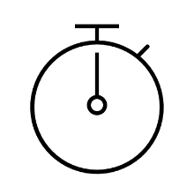 | Timatanga
To open your pepeha you may select a proverb that you identify with or use an opening you have been given.
- Tu ka ao, tu ka po, tu ka maranga ki te whai ki te ao marama e
  - As day and night pass we again find ourselves emersed in the light of new day
- E kore e piri te uku ki te rino
  - Clay will not adhere to steel
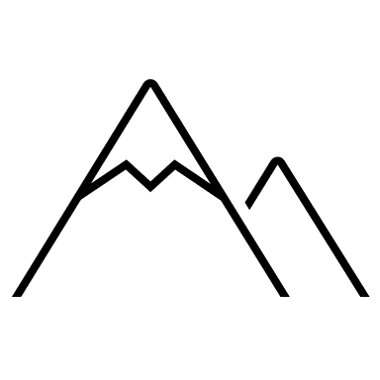 | Maunga
Maunga refer to prominant land features that are the authority that they represent. They can be drawn from your ancestral history or current locality.
- Ko Maungawhau te maunga
  - Mt Eden is my maunga
 | Awa
Awa were the vital providers and highways of traditional times. They can be drawn from ancestral history or current locality.
- Ko Oratira te awa
  - Oratira is my river
 | Moana
In some traditions some people may have a significant body of water that they associate with their identity, this can be a lake, a bay or even an ocean body.
- Ko te Rotorua Nui a Kahumatamoemoe te moana
  - Rotorua is my lake
 | Iwi
By acknowledging an iwi you claim lineage from an ancestor or tribal grouping.
- Ko Tainui taku iwi
  - My iwi is Tainui
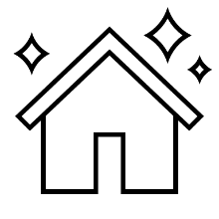 | Marae
A marae helps people identify what specific tribal group you may come from.
- Ko Mokotangatakotahi te marae
  - My marae is Mokotangatakotahi
Whānau
 | Hoa Tāne/Wāhine
You may choose to share the name of your partner.
- Ko Jenny taku hoa wahine
  - Jenny is my wife
- Ko Geoff taku hoa tane
  - Geoff is my husband
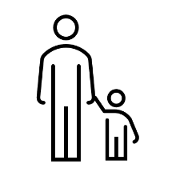 | Tamariki
You may choose to share the number of children you have and how many you have.
- E rua aku tamariki
  - I have two children
- Ko Evan me Joshua a rāua ingoa
  - Their names are Evan and Joshua
Ko Wai Au
 | Taku Ingoa
You can share you name.
- Ko Hemi taku ingoa
  - My name is Hemi
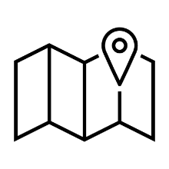 | No Hea Ahau
You can share where you are from. This can be currently or where you grew up.
- No te Waipounamu ahau
  - I am from the South Island
- No Waiheke ahau
  - I am from Waiheke Island

