MMH TIP’S & TRICKS

The more features you have available to patients, the more they will see its value and utilise the portal, which in turn creates more efficiency for your practice.

MMH hold webinars monthly. To register you can look at any patients MMH registration page and click on this link:
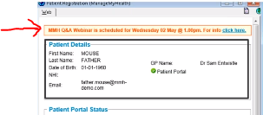

WHEN A PATIENT CAN’T VIEW THEIR RECORDS

This can happen for several reasons.
Firstly, the practice has the ability to view what records the patients can see.
This is helpful if they ring saying they can’t see certain things.

Instructions:
Bring the patient onto pallet
Click on the green MMH icon
Click on health summary record

(You must have clinical access ticked on your MMH staff set up to view the clinical summary.)
If you can see there is information missing, the next thing to do is click on the RESET UPLAOD option.
This option is on the patients registration screen. This will re-sync the patients Medtech info with MMH immediately.
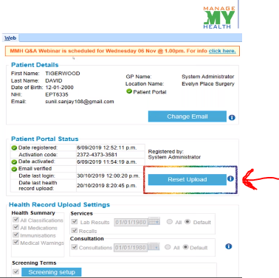
Other reasons why information may not be showing include:
- Medication may not be a long term condition or marked confidential
- The item may be ticked – do not upload to MMH

PATIENT REGISTRATION
Did you know it is not compulsory to enter an identification number on the patient registration page?
If you don’t want this as a mandatory field, write to support@managemyhealth.co.nz and let them know.

SCREENING
The practice can chose to allow screening entered in the practice to be downloaded into the patients MMH app. When setting this up, you can opt to exclude certain sensitive screening terms across the board if you wish.
Patients also have the ability to enter their own screening taken at home, eg; weight, peak flow, blood sugar, BP etc.
They can then track and graph these results which can really help when the patient has set goals and promotes self-care.
The practice can decide if they will let the screening taken by the patient to be uploaded into the PMS or not. Any screening taken from outside the practice will be available for clinicians to view in the MMH section of the screening tab. This will be kept separate from the practice screenings.

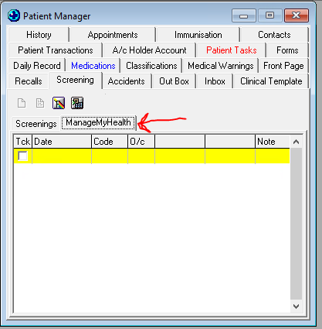

Benefits:
- Saves time in the consult as currently patients may come in with their screening written on paper for the Nurse to enter or observe.
- Can build interest and motivation in patients to track their screening to meet goals.
- All the info is kept in one place so won’t get lost.
- The practice has control over what screenings get uploaded and downloaded and by what dates.

PRACTICE DIRECTORY
Patients that are both registered OR not registered for MMH can view practice information via the MMH website.
Karori Medical Centre is a great example:

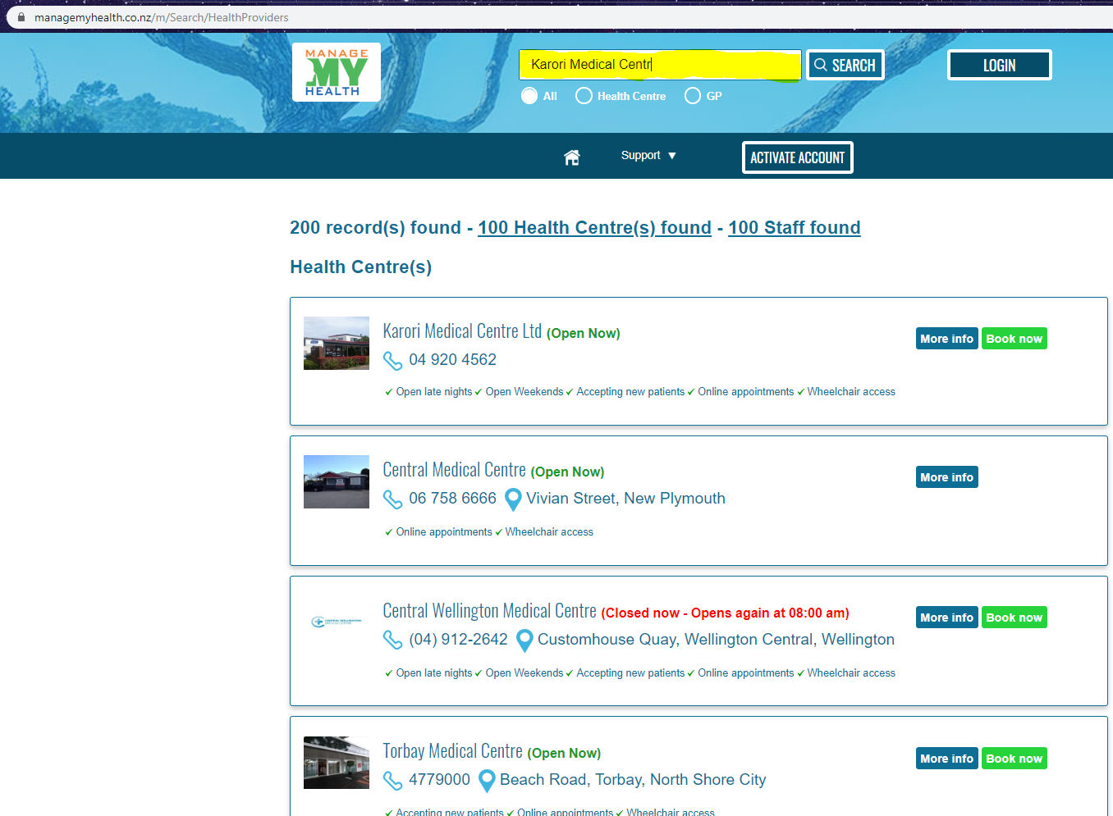

The pages are all customisable and you can click on ‘view output’ for a preview of what patient will see.
Benefits:
- You have control over what information you would like showing
- You can add a link to website if you don’t want to duplicate the information
- It’s FREE!
- You can add staff photos and profile descriptions
- You can add forms such as enrolments form, MMH form etc for patient to download

APP PUSH REMINDERS
Push reminders on the phone app happen when there are new lab results, a prescription has been approved or for an appointment reminder. Just like what you would see when you receive a new
E-mail or notification on your Facebook page.

RECALLS
Are you Nurses utilising the recall feature? Let Maria know if you would like her to come and spend some time with your Nurses to ensure full maximisation of this great functionality.
Benefits:
- Cost effective
- Secure
- Can see when it’s read/received – delivery status
- Customise – create the template in the outbox document for each recall or create one generic for all recalls
- Send with one click of a button

The next time the patient opens their app, the recall will pop up so they can’t miss seeing it. It will give two options: BOOK APPOINTMENT OR OK.

On the MMH website you can set up ‘pre recall reminders’ which are useful for giving patients a heads up that they are soon due for something. This can prompt them to book for this even before they receive the recall. This has been shown to improve the response rates and lessens the need for the practice to chase up the patient.
This runs in the background and does the work for you!

REPEAT SCRIPT INSTRUCTIONS

By reviewing the instructions patients receive when order scripts can help reduce phone calls or patients arriving to collect the script before it has come out of the Dr’s room.

Scenario: Patient orders script and gets approval massage so comes into practice to collect. Script is still with the Dr though.
Solution – set up repeat script pick up instructions.
You can customise a template and this gets sent to the patient alongside the message of the script approval. This is sent automatically to the patient as soon as the Dr clicks FILE.

You can advise to collect the script in a certain amount of time that your practice decides.
With clear instructions, this will reduce patient frustration.

Let Maria know if you would assistance with this.

APPOINTMENTS

Many practices around the country are using the appointment booking option for Nurse appointments.
Here’s a few things to consider:
- Over 50% of practices nationwide are using this feature for Doctors AND Nurse apts
- Customise the Apt terms and conditions in order to let the patient know what they can and cannot book in for eg: you may not allow apts to be booked that are longer than 15 mins
- Ensure you tick the Nurse clinic in the MMH staff set up – you do not need to ‘register’ this clinic like you do other staff as it will be used for apts only
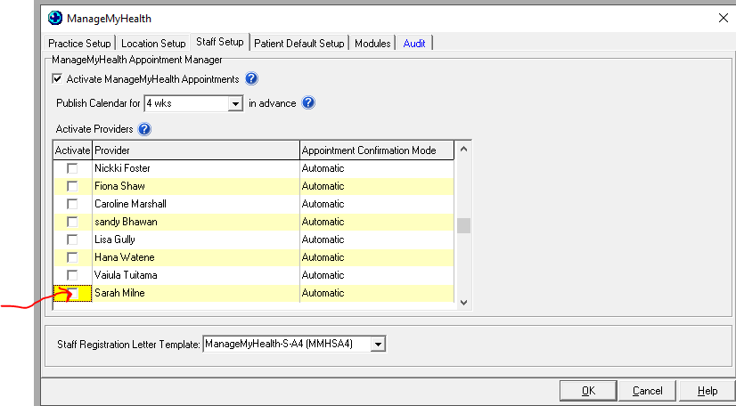

Blocking off apts that you don’t want patients to book via the portal.
This feature allows you to select up to 4 session names that you currently use and then the option to make these times with this session name unavailable to patients who are booking via the portal.
Go to: MMH website (must be system admin)
Apt settings
At the bottom of the page you can select session names

Same day bookings
If you would like your patients to be able to book on the day of booking you will need to advise the MMH team via support@managemyhealth.co.nz

NOTICE BOARD
You can use the notice board to post announcements / information you would like to communicate. The patient will get a notification advising them to look at the notice board as something new has been posted.

GROUP MESSAGING
This is a great feature. You can select different patient cohorts for example: all females over 65years and send a group message. They will receive an e-mail or a push notification (like you get when your e-mail app lets you know you have a new e-mail). Great for flu season, advising of a new portal feature or announcing extended hours to name a few.

MMH USER GUIDE
For more information of certain features, you can check out: Medtech/ManageMyHealth/Resources.

