Stocktake of HCH
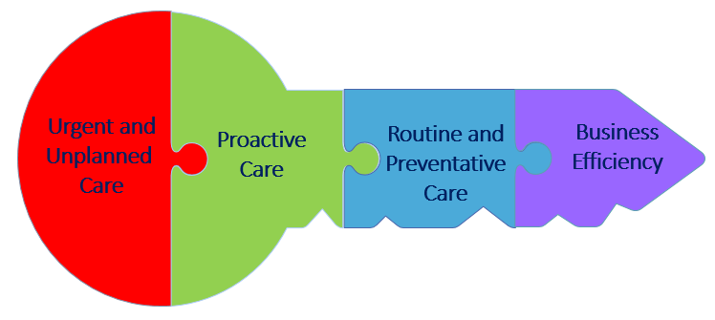
Requirement | Start Date | Next Steps | Target | Completed
GP Triage
Same day appointment availability
Extended Hours
Call management and call wait times.
Non-acute consultations over the phone, video and via secure email
Cultural Consideration
Care Planning and risk stratification
Patient self-management programmes
Pre-work for patients
Patient experience survey
Consumer co-design (Focus groups)
Web and Smart phone based portals
Lean Programme maturity
Staff Engagement survey
Facility
re-design
(phones off front desk)
General Practice Roles
(PCPA)
Workforce Development Plan

