CHANGE LEADERSHIP STARTS WITH YOU

Name My Current Role Organisation/Team

_________________________________ _______________________________ _____________________________
My top three change goals are:

1

2

3
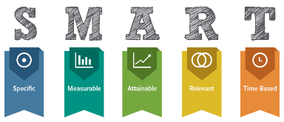
What does success look like with change facilitation?

What are my personal goals for progressing change?

Action over the next 6 months to improve my change facilitation skills

ACTIONS DUE
______________________________________________ ____________

