Virtual consultations within Indici

Provider Instructions

Getting started
Virtual consultations are managed through the patient portal myindici, patient must be registered and activated.
It is recommended that patients use the myindici app (available for download on iOS and Android). This is to reduce any potential troubleshooting you may be asked to do around microphones, cameras, webcams not working.

Equipment
You will need a webcam camera to plug into your PC for virtual consults

Costs
There is no additional cost to the practice or patient for using this service.
There are no additional charges for using the free version of Doxy. It will prompt you to upgrade your plan occasionally, but you don’t need to.

Part One: Doxy account and virtual space setup
Create Doxy account
Sign up as a provider  Creating a Doxy account is the easiest way to configure virtual consultation.  Note: This needs to be configured for each provider, with their email address. Then enter the URL sent via email to ‘My Settings’ within their logins.  To sign up for a Doxy account, navigate to https://doxy.me, and click on sign up for free, then select I’m a Provider.  Note: each provider will need to create their own account. | 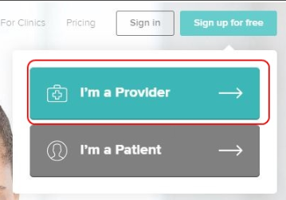

Setup virtual consult room  - A Sign-up page will appear, enter required information with a unique Room Name.  - This Room Name will be used for video consultation.  - Click on Sign Up. | 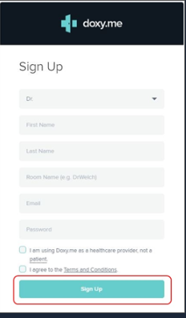

Part Two: Set up, book and run a Virtual Consult

Setting up Virtual Consults

Configure consult area
Before Providers can initiate virtual consultations, the following configurations need to be made per provider within indici
- Click Configurations > Configurations Dashboard > Patient Portal Settings > Video Consult Configurations > Provider Video Consult Configurations
- Tick enable Video Consult
- Complete integration with Zoom or Doxy
- Add the appropriate users to the right column, using the arrows
- Click update to save
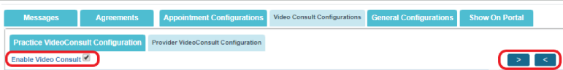

Select appointment types
- Under general configurations you can select the appointment types available on the patient portal
- Note: make sure these appointment types are available within the roster configurations

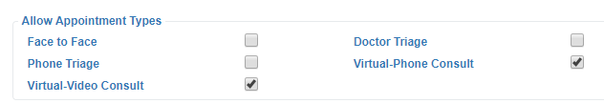

Edit Rosters

Configure roster
Rosters need to reflect the correct consult type to enable virtual consultations,
- Open the users roster settings, Administration > Staff Roster > Roster
- Find the appropriate user using the Provider search filed
- Click the edit button to open
- Open the existing recurrence patterns and make the required changes. Depending on preference,
  - Set appointments as F2F but allow Virtual Consult - Video to be booked into these slots
  - Select Virtual Consult- Video but allow F2F to be booked into these slots
  - Select Virtual Consult – Video for a set time within a session as dedicated virtual consult time
- Note: for ease of patients continuing to book appointments, option A is preferred.
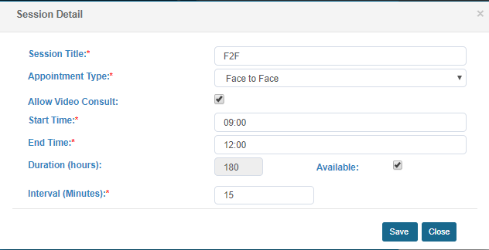
- Save all changes
- Save recurrence pattern
- Repeat process for all appropriate clinicians

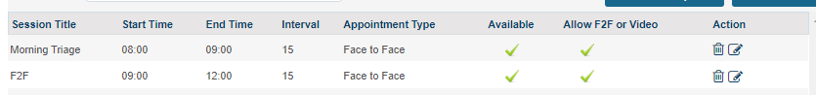

Book a virtual consult – from Indici

Find available booking slot
Rosters need to reflect the correct consult type to enable virtual consultations,
- Search patient
- Open the appointment book screen
- Book appointment into appropriate available video consult – video appointment slot or ensure appointment type is virtual consult – video
- Save


Booked appointment will have an icon of a video recorder.
Note: Patient will also be able to book my indici.

Beginning the virtual consult

Pre-requisites
Please ensure all of the following prerequisites are complete before continuing. If some aren’t configured correctly, virtual consultations won’t work.

- Doxy account created and configured against indici
- Providers enabled for virtual consults within myindici configurations
- Rosters include virtual consult appointment types
- Patient activated for myindici and video consult enabled within enrolment form
- Appointment booked

How the patient begins the virtual consult
- Login to myindici – via app
- Open Appointments > My Appointments
- The connect button will appear when one hour is left before appointment start time. Click the connect button to join
- Patients can update basic demographic information before the consult starts
- Patient then waits until Provider initiates consultation

How the provider begins the virtual consult
- Appointment will mark as arrived once patient has joined the virtual consult
- Open consultation
- Click blue video icon on toolbar – a separate tab will open
Note: Click Pre-Call Test to test microphone and camera if required

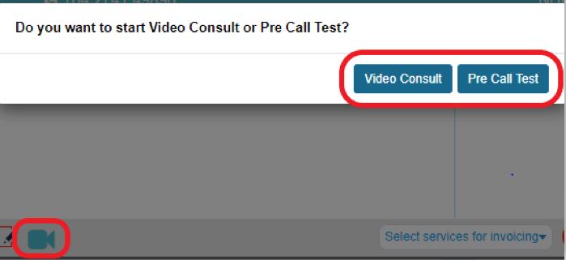

- Begin consultation

Within Doxy
Note: the first time you will be prompted to enter email address and password for Doxy, click remember me so you don’t have to do it again.
- Use the arrows – and x in the top corner to expand and minimise the video screen
- Click the three lines on the left to see the waiting room
- Click the video icon under the patient name to begin consultation
- A chat feature is included if required

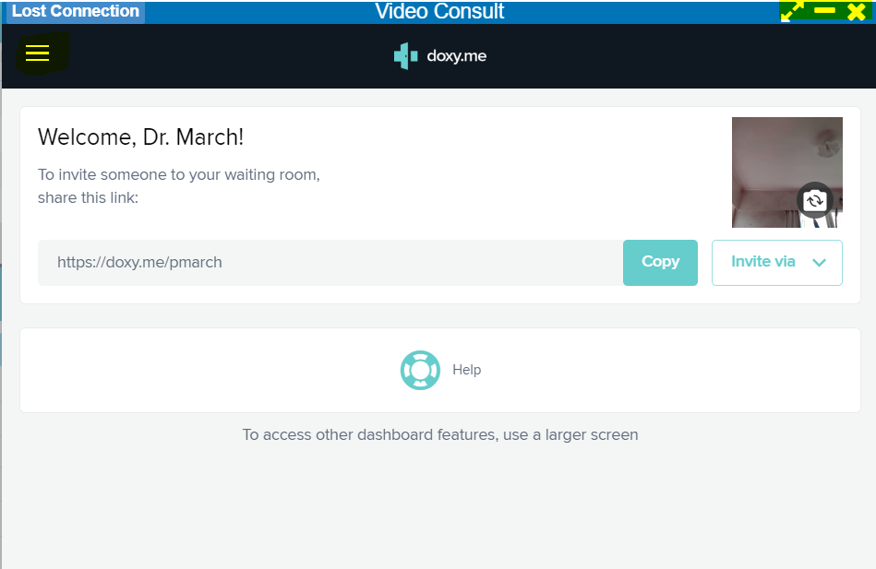

- At the end of the consultation, click the x within Doxy to close the virtual consult window
- Enter notes like usual
- select services and finish consultation like usual

Other items to note
Item to Note | Things to consider | Mitigations
- Video quality of Virtual Consult | - How many GPs are doing virtual consults at the same time?  - Quality of internet patient is using | - Turn of camera when/if not required
- Patient has technology issues e.g., webcam or microphone not working on a PC |  | - We suggest that patients use the app when entering a virtual consult (this is outlined in the patient handout)

Here is a link to a video explaining the different ways video consults can be configured - https://drive.google.com/open?id=1s11MHBY0_o64--MAgTHOHzb5KyjOBmGm

